**Arief Fitranto – Full Stack Developer Portfolio**

1. **Project Name: Conrad Maldives Rangali Island**
   * **Technologies:** PHP, Wordpress, Javascript, Meta Pixel, GTM, jQuery
   * **Link:** <https://www.conradmaldives.com/>

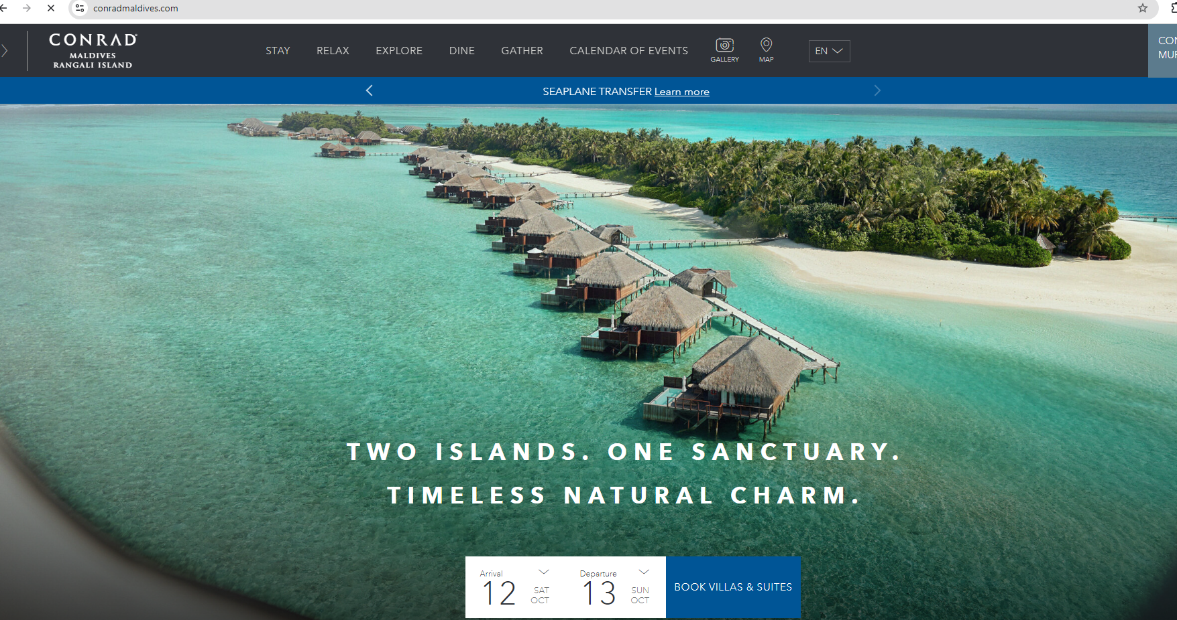

1. **Project Name: West Hotel Sydney**
   * **Technologies:** PHP, Wordpress, Javascript, Open Graph, GTM, jQuery
   * **Link:** <https://www.westhotel.com.au/>

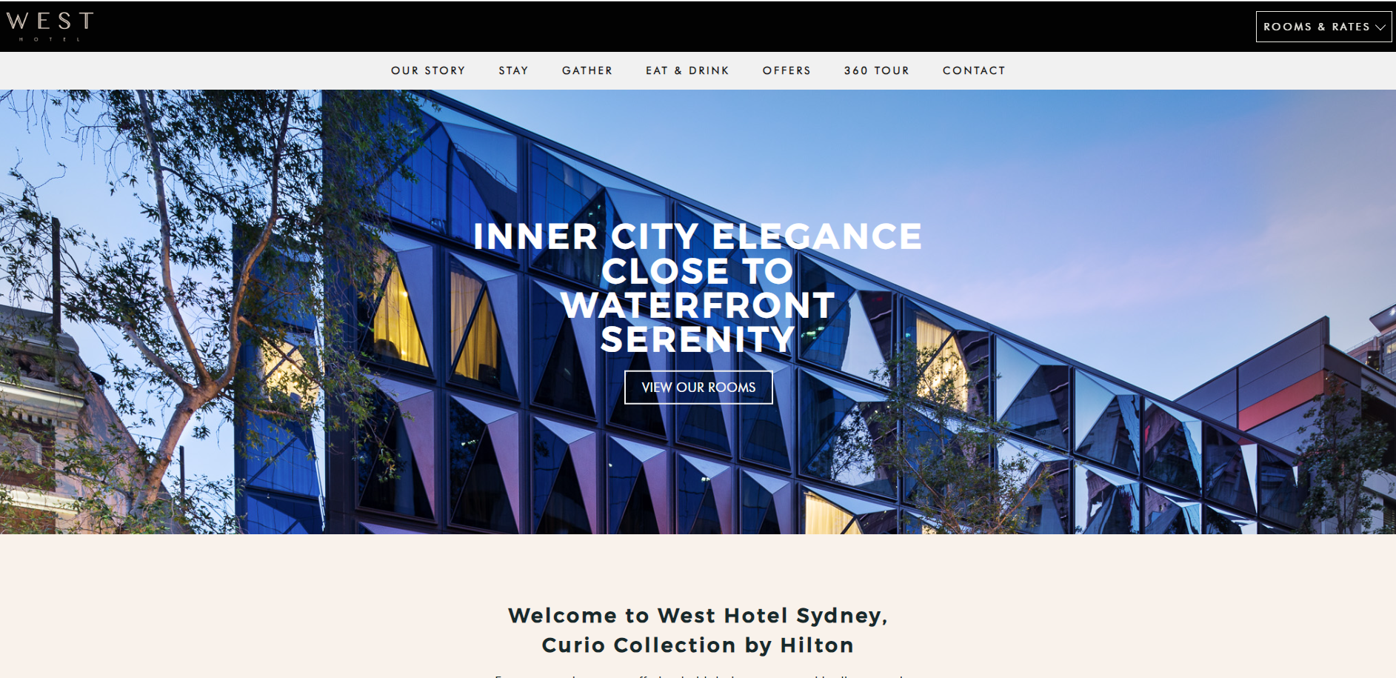

1. **Project Name: Glass Brasserie**
   * **Technologies:** PHP, Wordpress, Javascript, Modernizr, GTM, jQuery
   * **Link:** <https://www.glassbrasserie.com.au/>

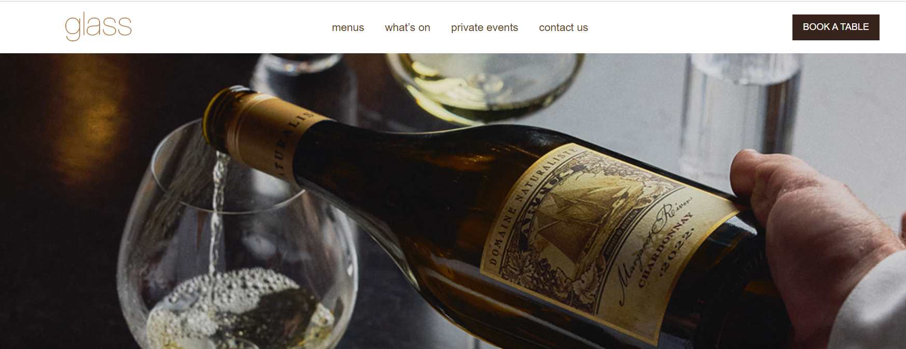

1. **Project Name: Hilton Sydney**
   * **Technologies:** PHP, Wordpress, Javascript, Modernizr, GTM, jQuery
   * **Link:** <https://www.hiltonsydney.com.au/>

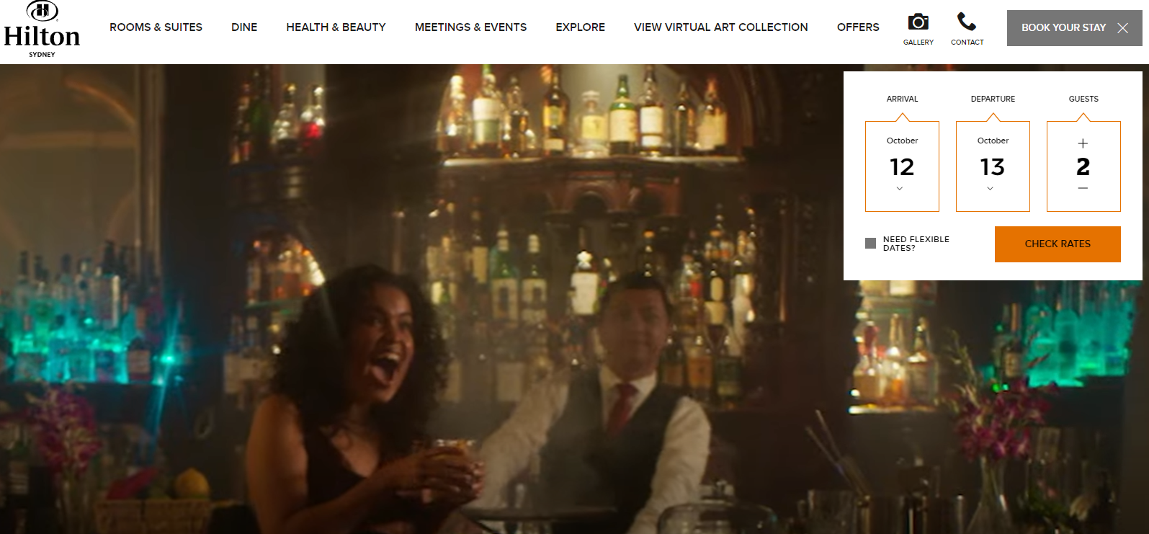

1. **Project Name: Mondo on the Waterfront - Hilton Cairns**
   * **Technologies:** PHP, Wordpress, Javascript, Modernizr, GTM, jQuery
   * **Link:** <https://mondoonthewaterfront.com.au>

**(discontinue / hotel closed)**

1. **Project Name: Samuels on Mill - Parmelia Hilton Perth**
   * **Technologies:** PHP, Wordpress, Javascript, Modernizr, GTM, jQuery
   * **Link:** <https://www.samuelsonmill.com/>

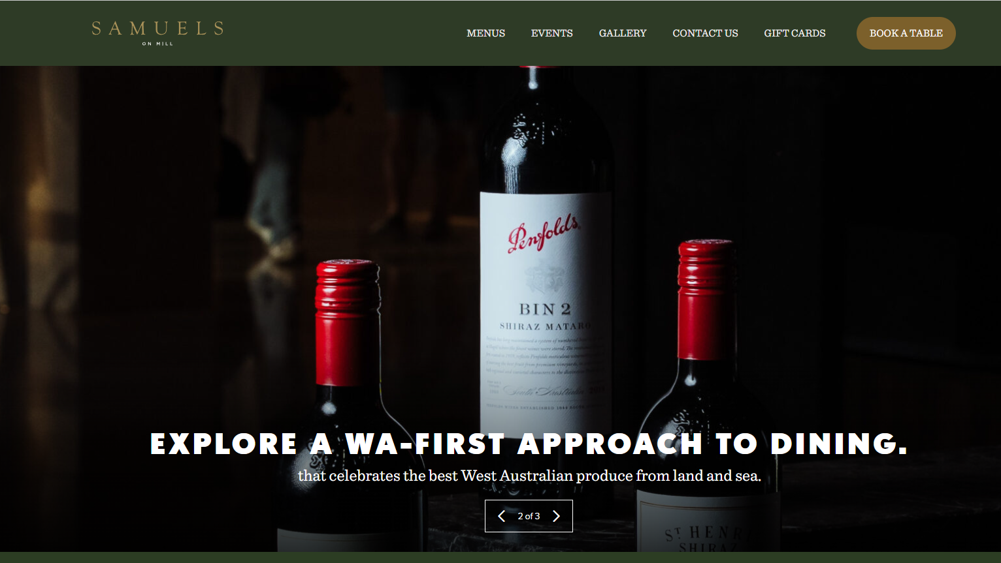

1. **Project Name: Vintaged Bar + Grill**
   * **Technologies:** PHP, Wordpress, Javascript, Modernizr, GTM, jQuery
   * **Link:** <https://www.vintagedbarandgrill.com/>

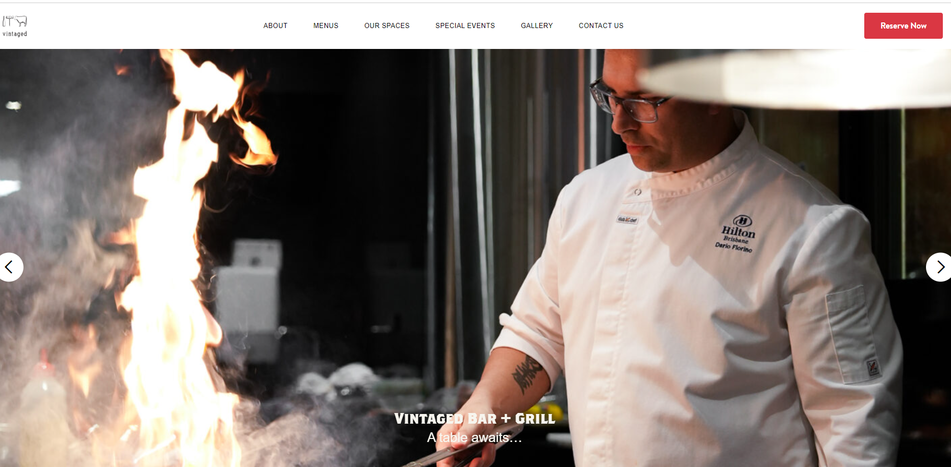

1. **Project Name: James St Bar + Kitchen** 
   * **Technologies:** PHP, Wordpress, Javascript, GTM, jQuery
   * **Link:** <https://www.jamesstbarandkitchen.com/>

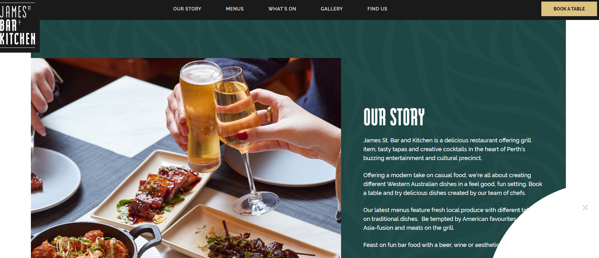

1. **Project Name: Solander Dining and Bar**
   * **Technologies:** PHP, Wordpress, Javascript, Modernizr, GTM, jQuery
   * **Link:** <https://www.solanderdiningandbar.com.au/>

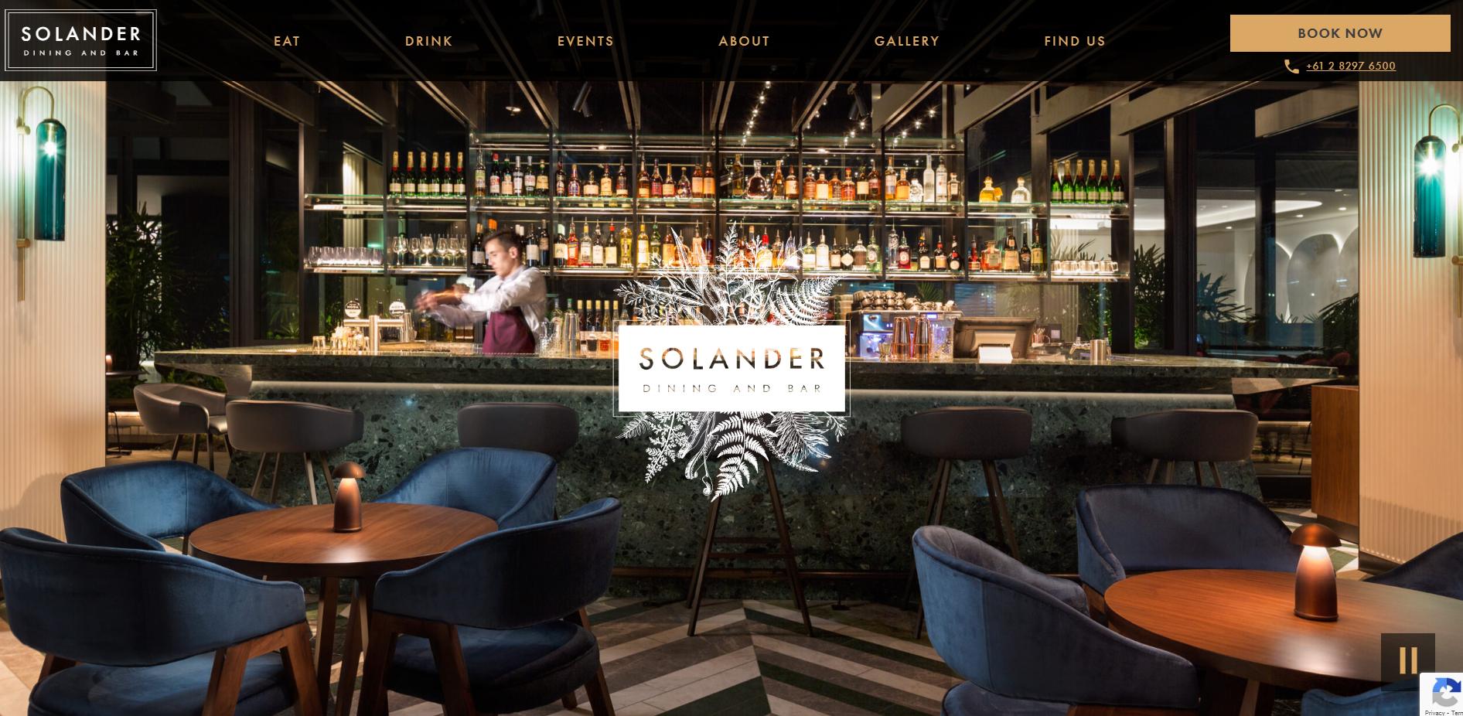

1. **Project Name: Marble Bar**
   * **Technologies:** PHP, Wordpress, Javascript, Modernizr, GTM, jQuery
   * **Link:** <https://www.marblebarsydney.com.au/>

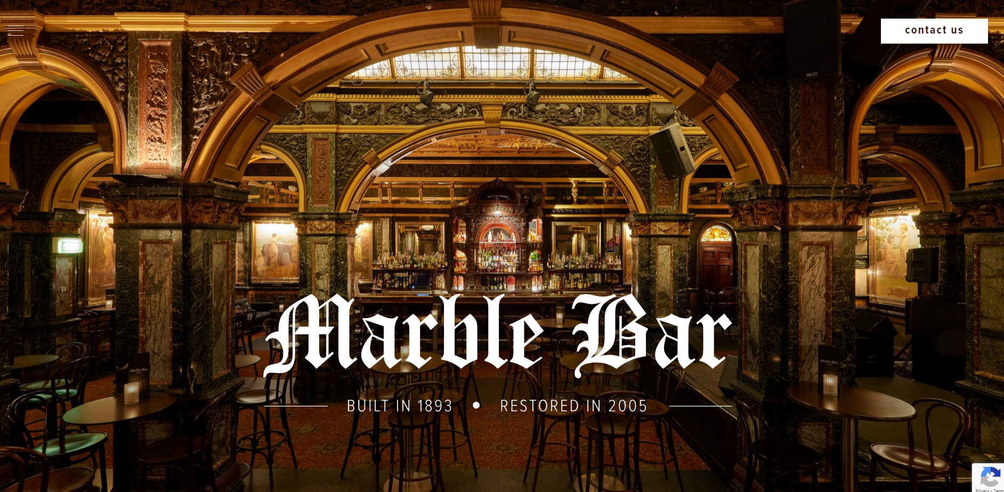

1. **Project Name: Marble Bar**
   * **Technologies:** PHP, Wordpress, Javascript, Modernizr, GTM, jQuery
   * **Link:** <https://www.zetabar.com.au/>



1. **Project Name: Citosmagz**
   * **Technologies:** PHP, Wordpress, Javascript, jQuery
   * **Link:** <https://www.citosmagz.com>

**(discontinue)**

1. **Project Name: Citos ID**
   * **Technologies:** PHP, Laravel, Javascript, jQuery
   * **Link:** <https://www.citos.id/>

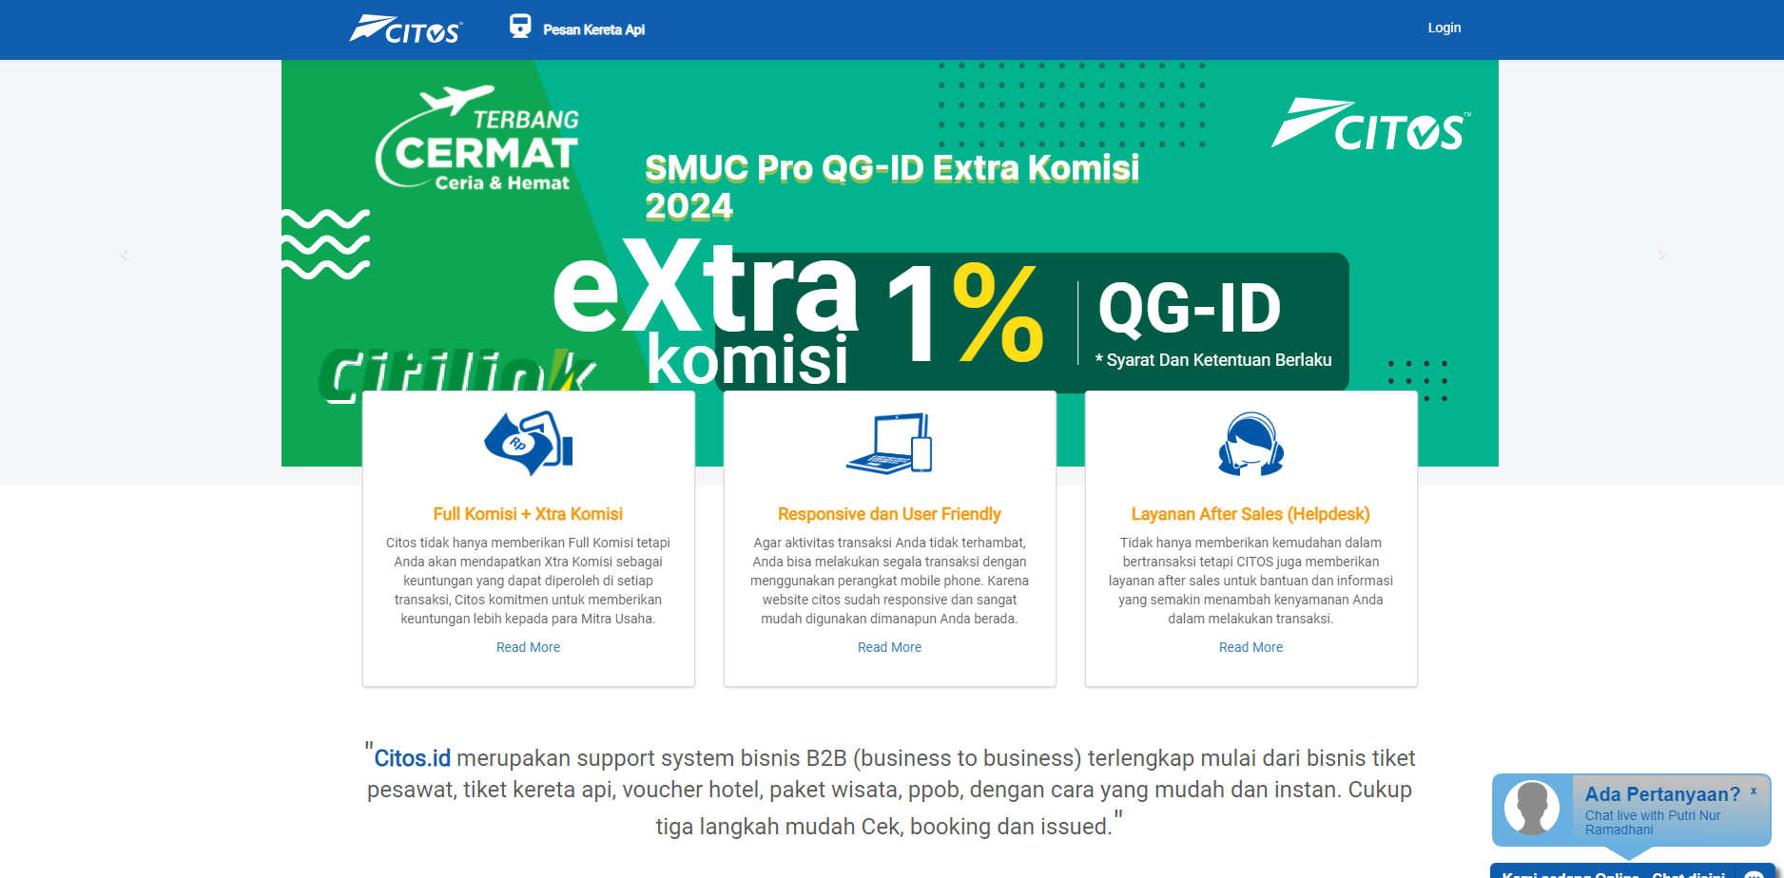

1. **Project Name: ARIF Platform**
   * **Technologies:** C#, React.js, Next.js, Python
   * **Link:** <https://goarif.co/>



1. **Project Name: Clenovio**
   * **Technologies:** PHP, JavaScript, Laravel, REST APIs, Unity
   * **Link**: <https://play.google.com/store/apps/details?id=com.clenovio.nusantara&hl=id>,

<https://clenovio.com/>

**(discontinue)**

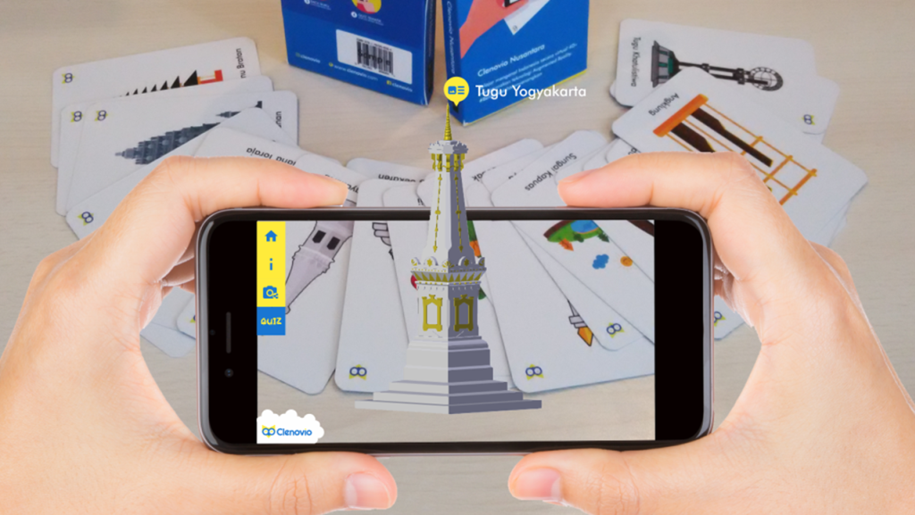

1. **Project Name: Pesona Security**
   * **Technologies:** PHP, JavaScript, CodeIgniter
   * **Link**: <http://pesonasecurity.co.id/>

**(discontinue)**

1. **Project Name: Paramount Students Mobile App**
   * **Technologies:** PHP, Laravel, RestAPIs
   * **Link**: <https://www.paramountstudents.com/>,

<https://play.google.com/store/apps/details?id=com.paramountstudents&hl=en>

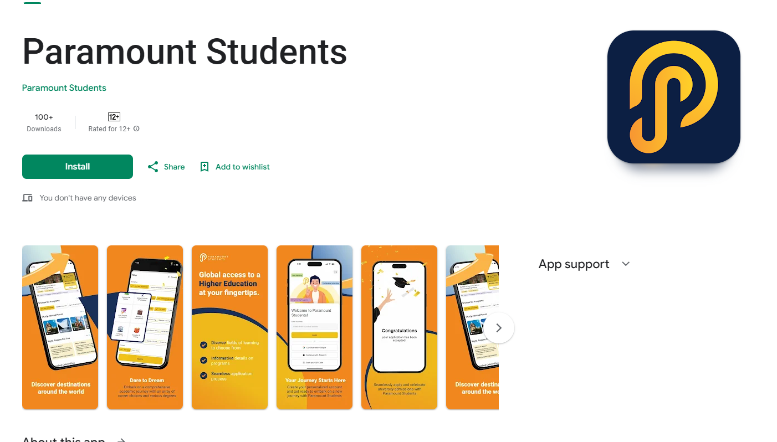

1. **Project Name: Skinceuticals**
   * **Technologies:** PHP, CodeIgniter, Javascript
   * **Link**: <https://www.skinceuticals.com/>



1. **Project Name: Bayer Plus**
   * **Technologies:** PHP, Laravel, Javascript, .NET, C#
   * **Link**: <https://www.bayer.com/>, <https://www.mybayerplus.com/>



1. **Project Name: YSL Beauty Singapore**
   * **Technologies:** PHP, Codeigniter, Javascript, jQuery
   * **Link**: <https://www.yslbeauty.com.sg/>

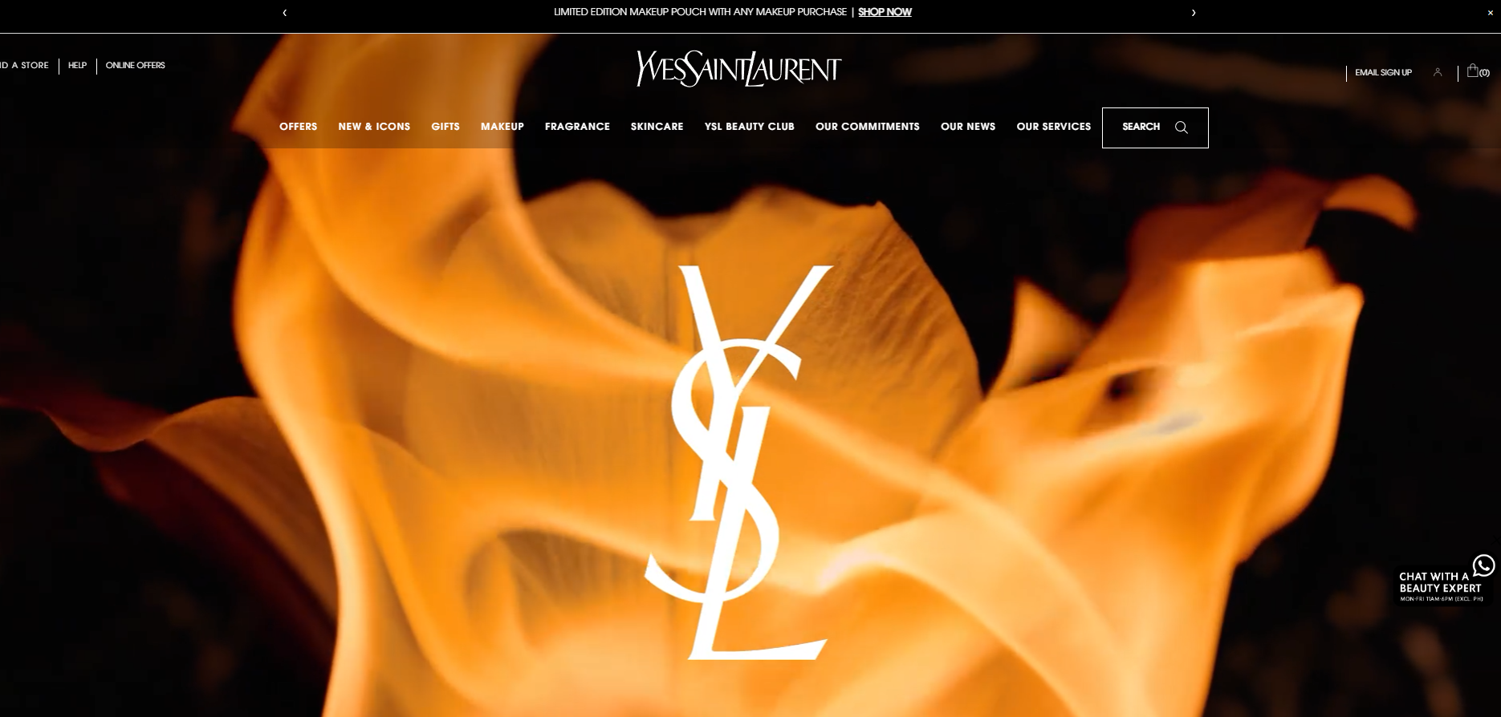

1. **Project Name: Loreal Singapore** 
   * **Technologies:** PHP, Laravel, Javascript, jQuery
   * **Link**: <https://www.loreal-paris.com.sg/>



1. **Project Name: Kerastase Malaysia** 
   * **Technologies:** PHP, Codeigniter, Javascript, jQuery
   * **Link**: <https://www.kerastase.com.my/en>

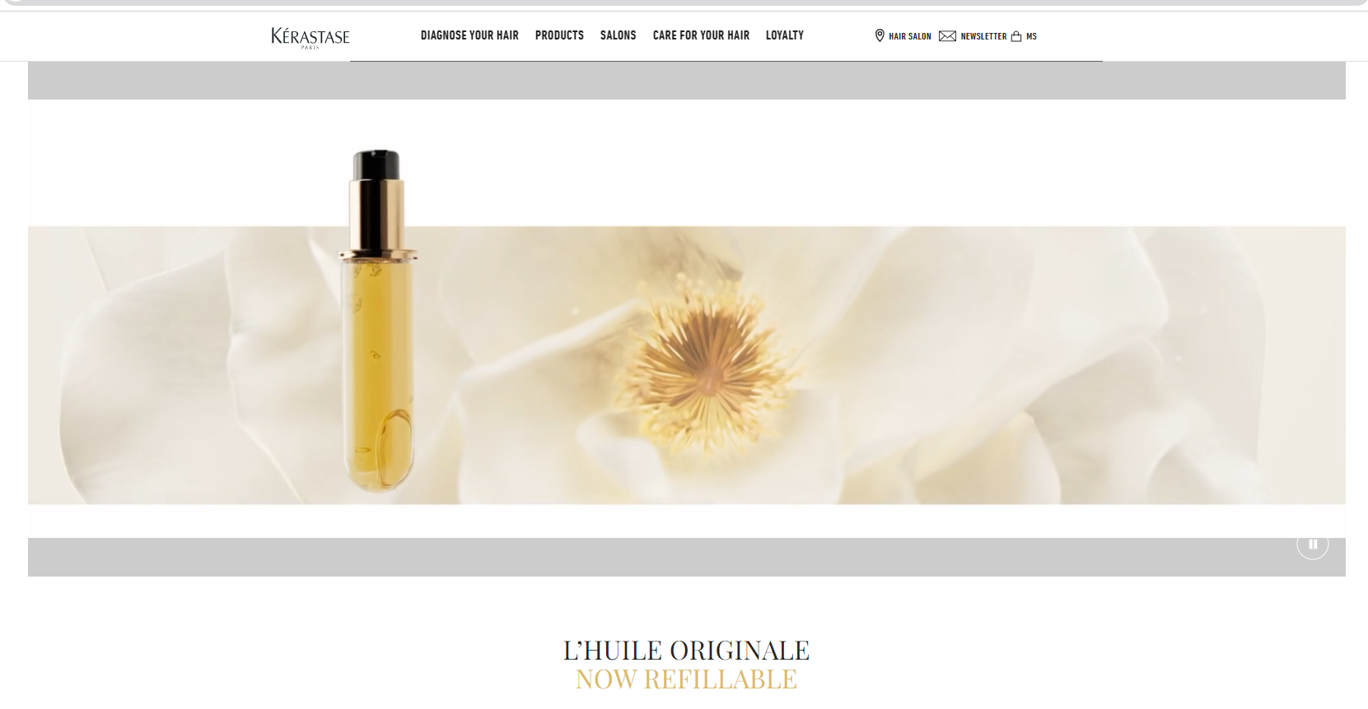

1. **Project Name: GUCCI , GUCCI Popup**
   * **Technologies:** PHP, Laravel, Javascript, jQuery
   * **Link**: <https://www.gucci.com/us/en/>



1. **Project Name: Armany Beauty Malaysia**
   * **Technologies:** PHP, Codeigniter, Javascript, jQuery
   * **Link**: <https://www.armanibeauty.com.my/>

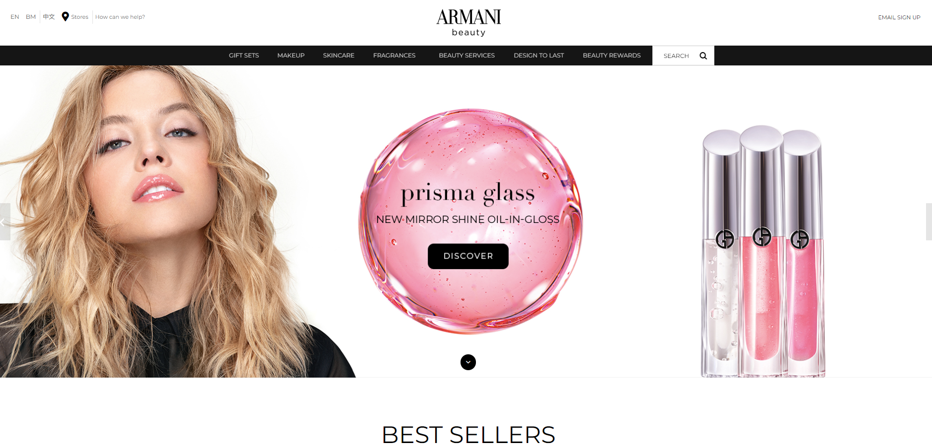

1. **Project Name: Viagoo Logistic**
   * **Technologies:** PHP, Yii, Javascript, jQuery, GeoLocation
   * **Link**: <https://sg.viagoo.co/>



1. **Project Name: FleetNexG Logistic (Parkway, PNI)**
   * **Technologies:** PHP, Yii, Javascript, jQuery, GeoLocation
   * **Link**: <https://www.nexg-sg.com/fleetnexg/>



1. **Science Centre Singapore**
   * **Technologies:** PHP, Laravel, Javascript, jQuery, Tailwind, Alpine, Livewire, Vue.js
   * **Link**: <https://rewards.science.edu.sg>, <https://www.science.edu.sg/>

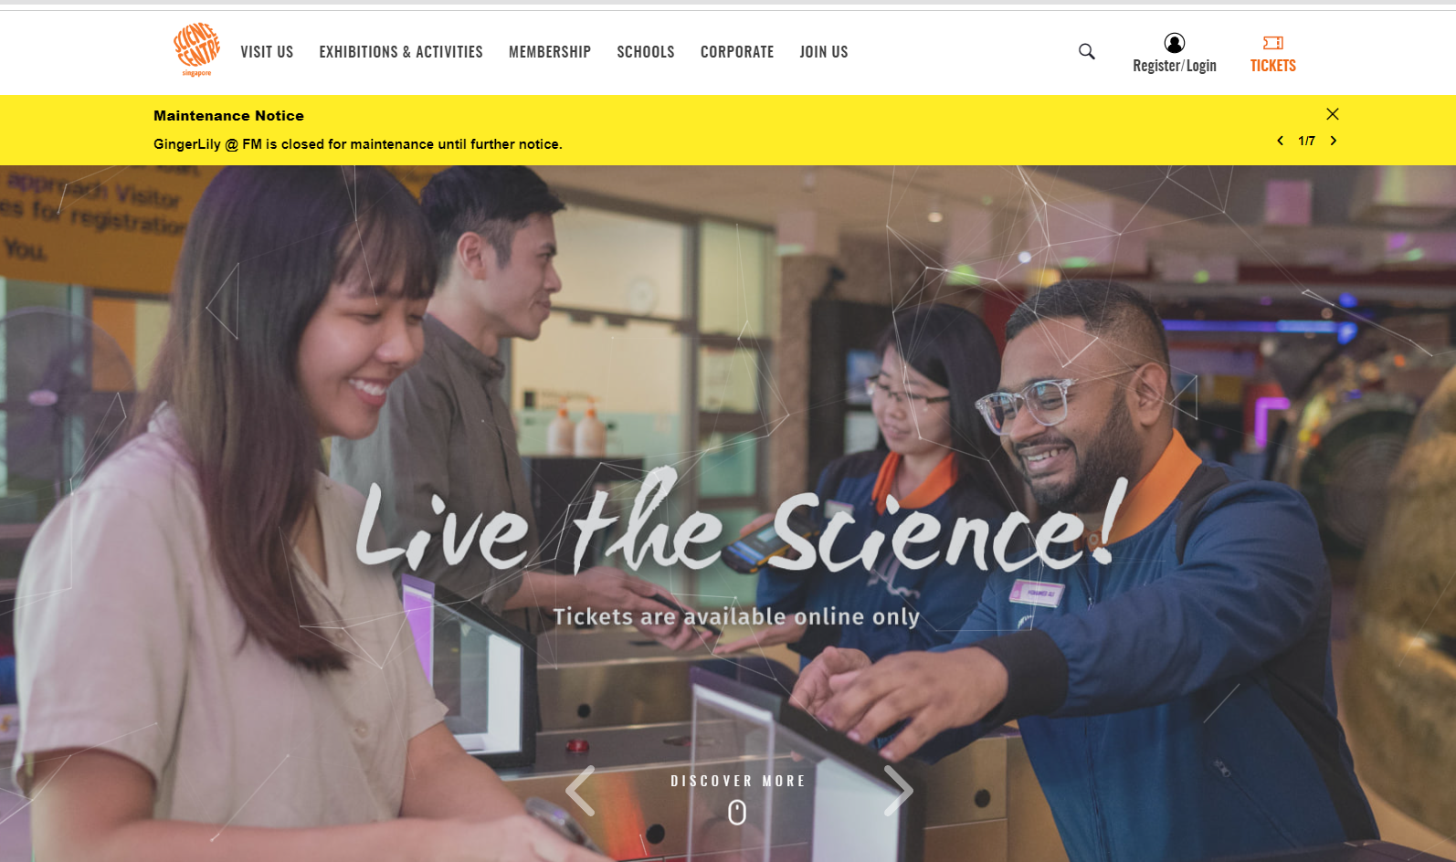

1. **Excellence Asia**
   * **Technologies:** PHP, CodeIgniter, Javascript, jQuery,
   * **Link**: <https://excellence.asia>

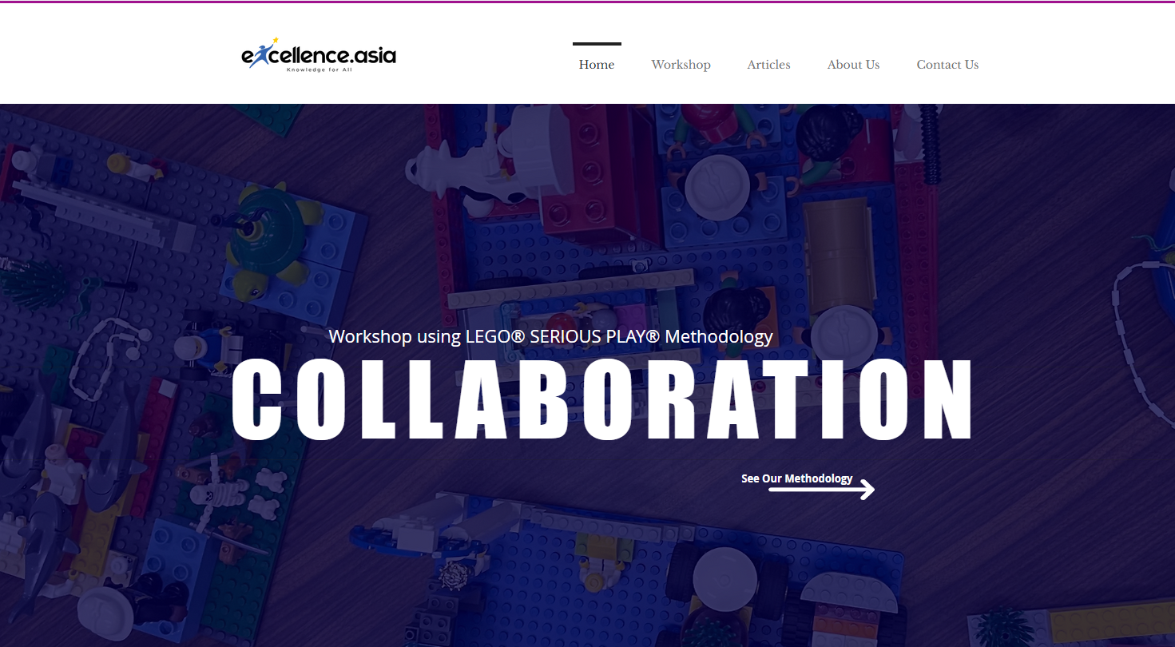

1. **Cerave Arabia - Reward**
   * **Technologies:** Javascript, Next.Js
   * **Link**: <https://www.ceravearabia.com/en>

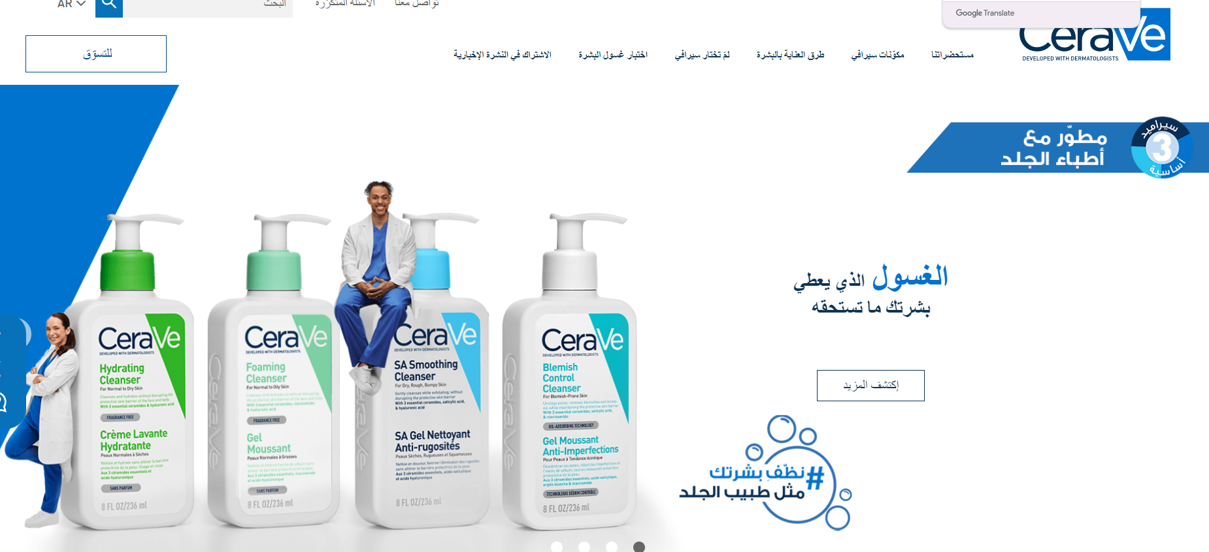

1. **Banyan Tree House**
   * **Technologies:** Node Js, Angular, REST APIs
   * **Link**: <https://www.banyantree.com/>

